**HW #13 (Project Evaluation)**

GK Posted April 2023

**Instructions:**

Please respond with your own words and own understanding. Copying the answers without understanding them, defeats the purpose of this homework -- it violates the code of ethics and the integrity of the course.

* *If you are* ***suspected*** *of copying any part of your answers either from a classmate or a web site (without a reference link), you get a zero to the entire homework.*
* *If it is* ***proven*** *that you have copied or plagiarized, you will be reported to your advisor, your sponsor, and the School; serious consequences to your academic record and/or your student status should follow.*
* *This is applicable to both the giving student and the recipient student*.

Please use font Arial or Calibri of 9pts or 10pts.

## (70pts) Project Classification

Consider your own project.

1. Write Project Title
2. (40pts) Self-evaluate this project across the NTCP dimensions, as discussed in Class #13, using grades of 1(lowest)…5(highest). For each dimension, explain your answer; you may also use comparisons with other projects discussed in the class. Single paragraph explanation per dimension is sufficient.
3. (30pts) Create the Spider Diagram of above – preferably (but not required) using Excel

**Answer:**

* 1. Centralized Alternative Solution for Enterprise Computing Needs
  2. Novelty: 3, comparing to cloud computing, this idea is not novel but helps company to fully control their server and data.  
     Technology: 2, running a whole set of server and customizing software tool chain are mature technology.  
     Complexity: 4, the solutions provided to different companies need to be based on their corresponding production environment and requirements, and this process is complex.  
     Pace: 4, according to the pert graph, this project has only 2 subtasks that are time slack, which means it is time critical.
  3. 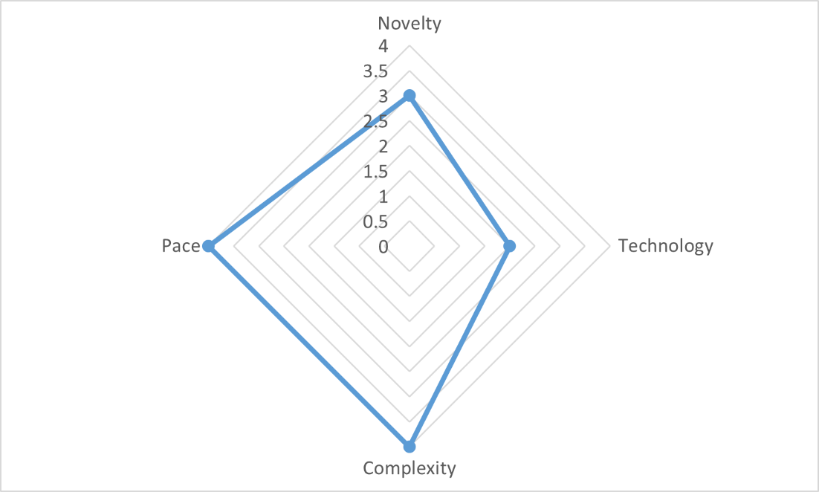

## (30pts) Project Success

Consider your own project.

Consider the four Success Dimensions as discussed in Class #13. ***For each dimension***, define the respective timeframe and explain. Example:

“the Impact to the Customer” of my project will be apparent between 6mo-12mo after the mobile application is released because…

**Answer:**

The “Project Efficiency” of my project will be at least 3 years because the service it designs is meant to be stable and enduring.

The “Impact on Customer” will be as long as the lifecycle of the service.

The “Business Success” of the project will be 6 months for it lacks of novelty and technology difficulties. The competitors of the large company will catch up immediately.

“Prepare the Future” will be 3 months or shorter. If not, the first-mover advantage will be lost immediately.